Fan Triangulation
# Source: AI Source: Provided by: [Data Path: Persons Table -> ID Column: 1, Name_En Column: Motasem Essam] -> From: [ChatGPT] on [7/25/2026]
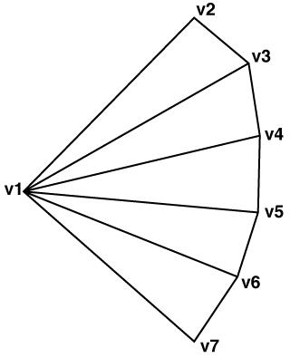
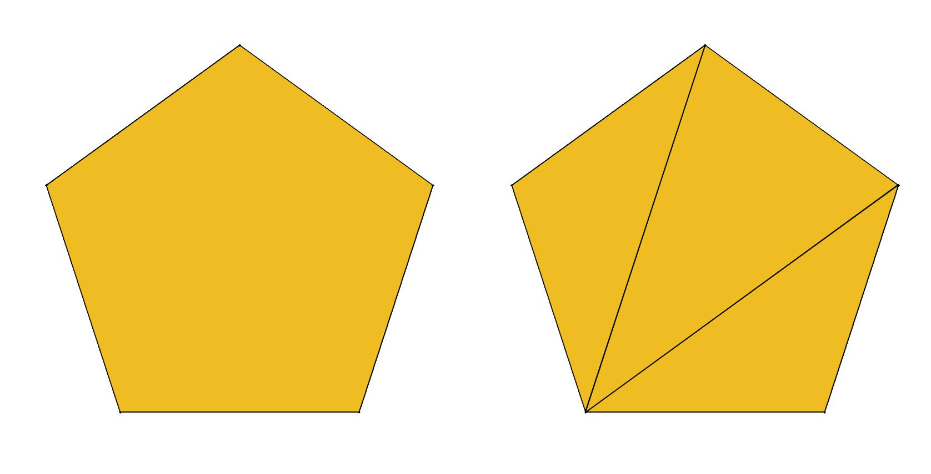
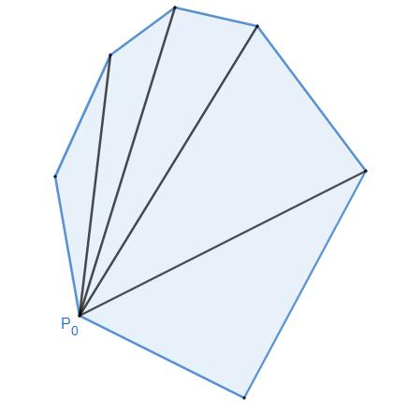
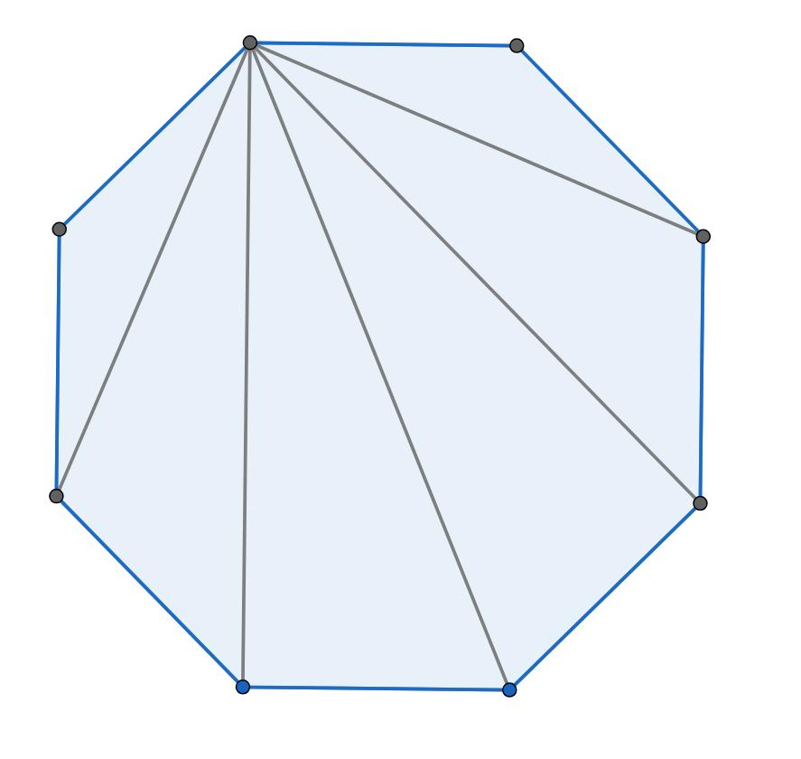
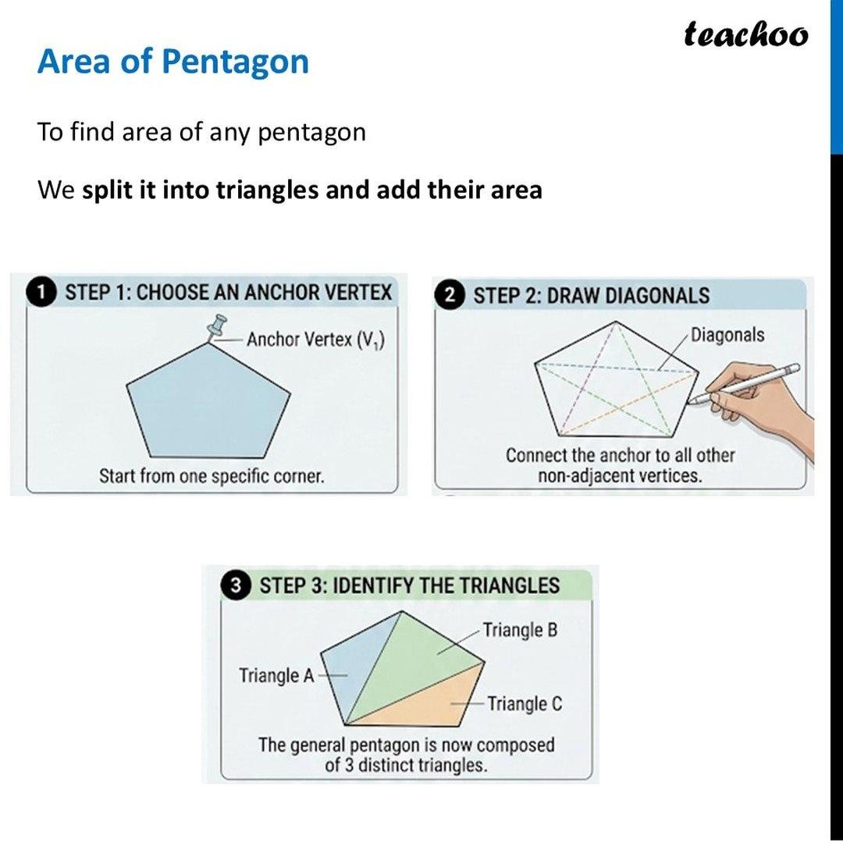

Definition
# Source: AI Source: Provided by: [Data Path: Persons Table -> ID Column: 1, Name_En Column: Motasem Essam] -> From: [ChatGPT] on [7/25/2026]
Fan Triangulation is a method of triangulating a polygon by selecting one vertex and drawing diagonals from that vertex to all non-adjacent vertices.
These diagonals form a fan-like arrangement and divide the polygon into triangles.
For an $n$-sided polygon:
$$\boxed{\text{Diagonals used}=n-3}$$
and
$$\boxed{\text{Triangles produced}=n-2}$$

Fundamental Concept
# Source: AI Source: Provided by: [Data Path: Persons Table -> ID Column: 1, Name_En Column: Motasem Essam] -> From: [ChatGPT] on [7/25/2026]
Consider a polygon $ABCDEFGH$.
If vertex $A$is selected as the fan vertex, draw diagonals:
$$\overset{‾}{AC}, \overset{‾}{AD}, \overset{‾}{AE}, \overset{‾}{AF}, \overset{‾}{AG}$$
These diagonals divide the octagon into:
$$△ABC, △ACD, △ADE, △AEF, △AFG, △AGH$$
Thus:
$$8-3=5$$
diagonals produce:
$$8-2=\boxed{6}$$
triangles.

Structure of Fan Triangulation
# Source: AI Source: Provided by: [Data Path: Persons Table -> ID Column: 1, Name_En Column: Motasem Essam] -> From: [ChatGPT] on [7/25/2026]
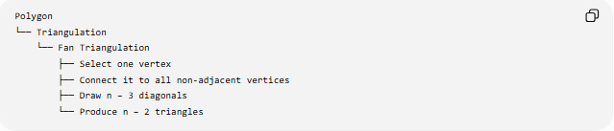
Polygon
└── Triangulation
└── Fan Triangulation
├── Select one vertex
├── Connect it to all non-adjacent vertices
├── Draw n − 3 diagonals
└── Produce n − 2 triangles
The selected vertex is called the fan vertex.

Fan Vertex
# Source: AI Source: Provided by: [Data Path: Persons Table -> ID Column: 1, Name_En Column: Motasem Essam] -> From: [ChatGPT] on [7/25/2026]
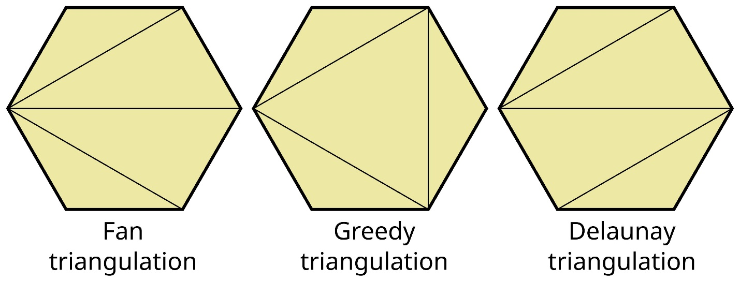
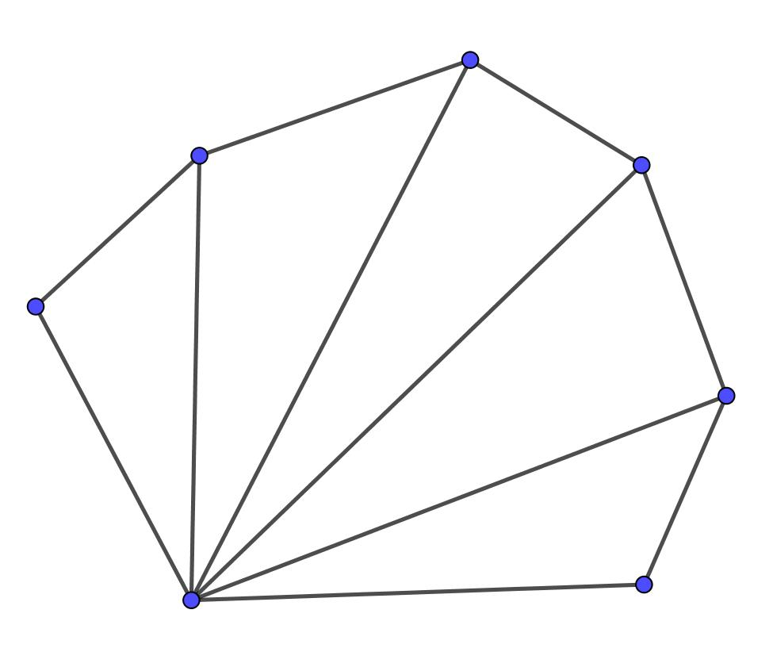
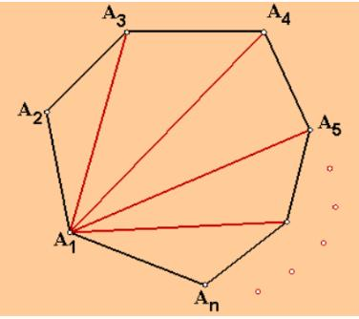
The fan vertex is the vertex from which all the triangulation diagonals originate.
For an $n$-sided polygon, a fan vertex has:
$$\boxed{n-3}$$
triangulation diagonals extending from it.
For example, in a decagon:
$$10-3=\boxed{7}$$
diagonals originate from the selected fan vertex.

How Fan Triangulation Works
# Source: AI Source: Provided by: [Data Path: Persons Table -> ID Column: 1, Name_En Column: Motasem Essam] -> From: [ChatGPT] on [7/25/2026]
Step 1 — Choose a vertex
Select any suitable vertex of the polygon.
Step 2 — Identify non-adjacent vertices
The two vertices directly connected to the selected vertex by polygon sides cannot be used because those connections are already sides, not diagonals.
Step 3 — Draw the diagonals
Connect the selected vertex to every non-adjacent vertex.
Step 4 — Obtain the triangles
The diagonals divide the polygon into triangular regions.

Formula
# Source: AI Source: Provided by: [Data Path: Persons Table -> ID Column: 1, Name_En Column: Motasem Essam] -> From: [ChatGPT] on [7/25/2026]
For an $n$-sided polygon:
Number of diagonals from the fan vertex
$$\boxed{D=n-3}$$
Number of triangles
$$\boxed{T=n-2}$$
Relationship
$$\boxed{T=D+1}$$

Examples
# Source: AI Source: Provided by: [Data Path: Persons Table -> ID Column: 1, Name_En Column: Motasem Essam] -> From: [ChatGPT] on [7/25/2026]
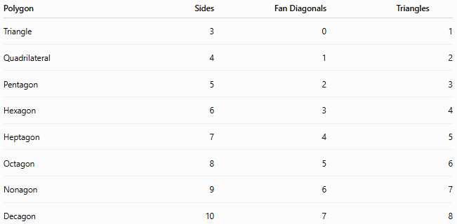
Polygon | Sides | Fan Diagonals | Triangles
Triangle | 3 | 0 | 1
Quadrilateral | 4 | 1 | 2
Pentagon | 5 | 2 | 3
Hexagon | 6 | 3 | 4
Heptagon | 7 | 4 | 5
Octagon | 8 | 5 | 6
Nonagon | 9 | 6 | 7
Decagon | 10 | 7 | 8

Fan Triangulation of a Pentagon
# Source: AI Source: Provided by: [Data Path: Persons Table -> ID Column: 1, Name_En Column: Motasem Essam] -> From: [ChatGPT] on [7/25/2026]
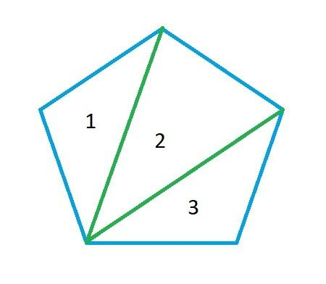

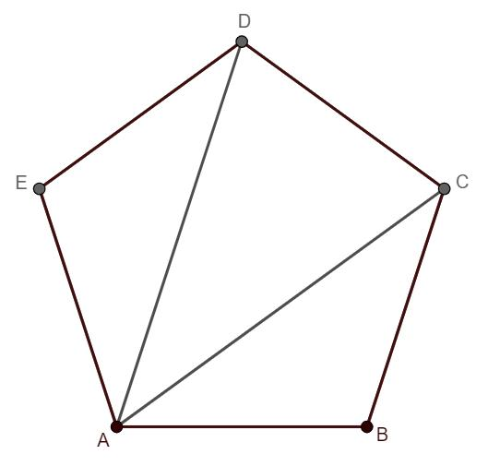
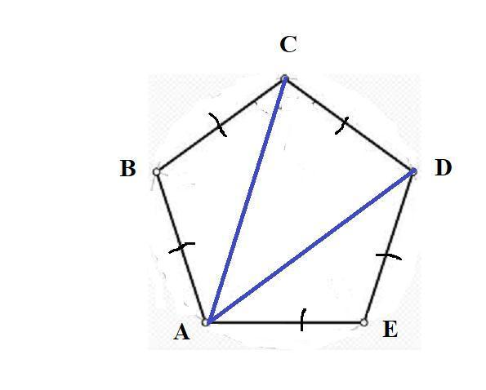
For pentagon $ABCDE$, choose $A$as the fan vertex.
Draw:
$$\overset{‾}{AC}$$
and
$$\overset{‾}{AD}$$
This creates:
$$△ABC, △ACD, △ADE$$
Therefore:
$$5-3=\boxed{2\text{ diagonals}}$$
and
$$5-2=\boxed{3\text{ triangles}}$$

Fan Triangulation of a Decagon
# Source: AI Source: Provided by: [Data Path: Persons Table -> ID Column: 1, Name_En Column: Motasem Essam] -> From: [ChatGPT] on [7/25/2026]
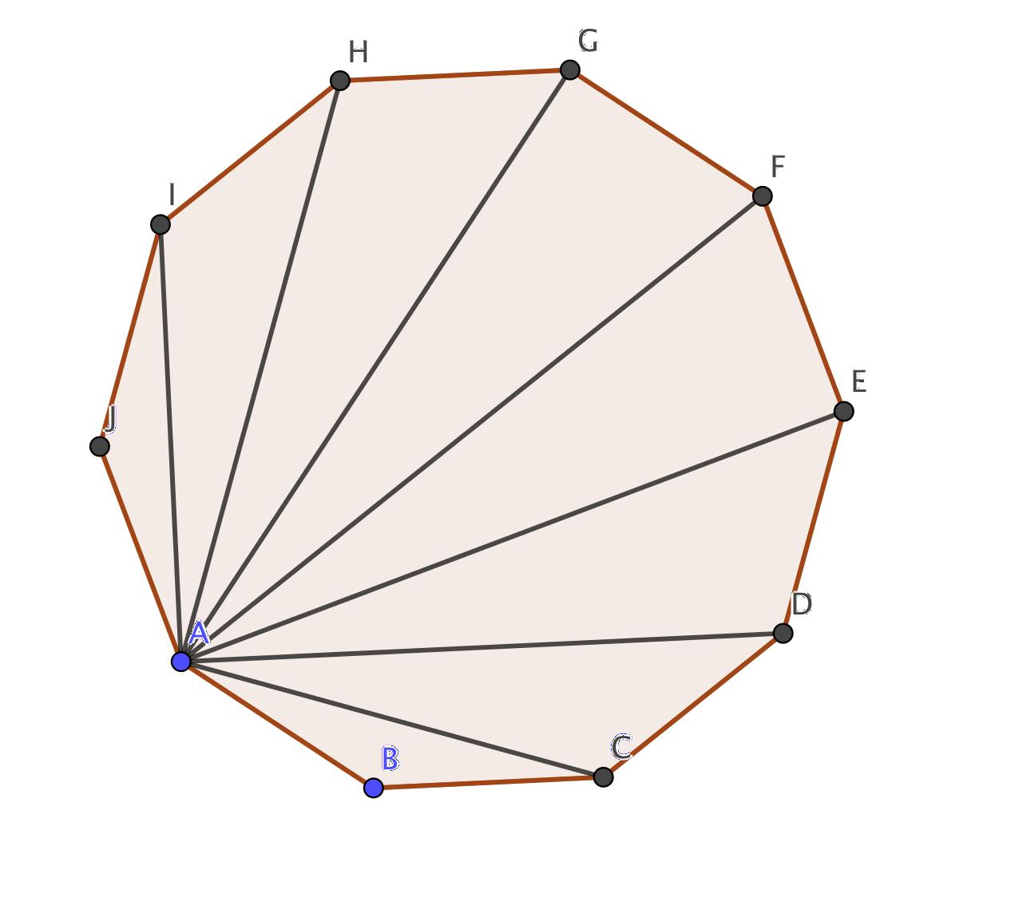
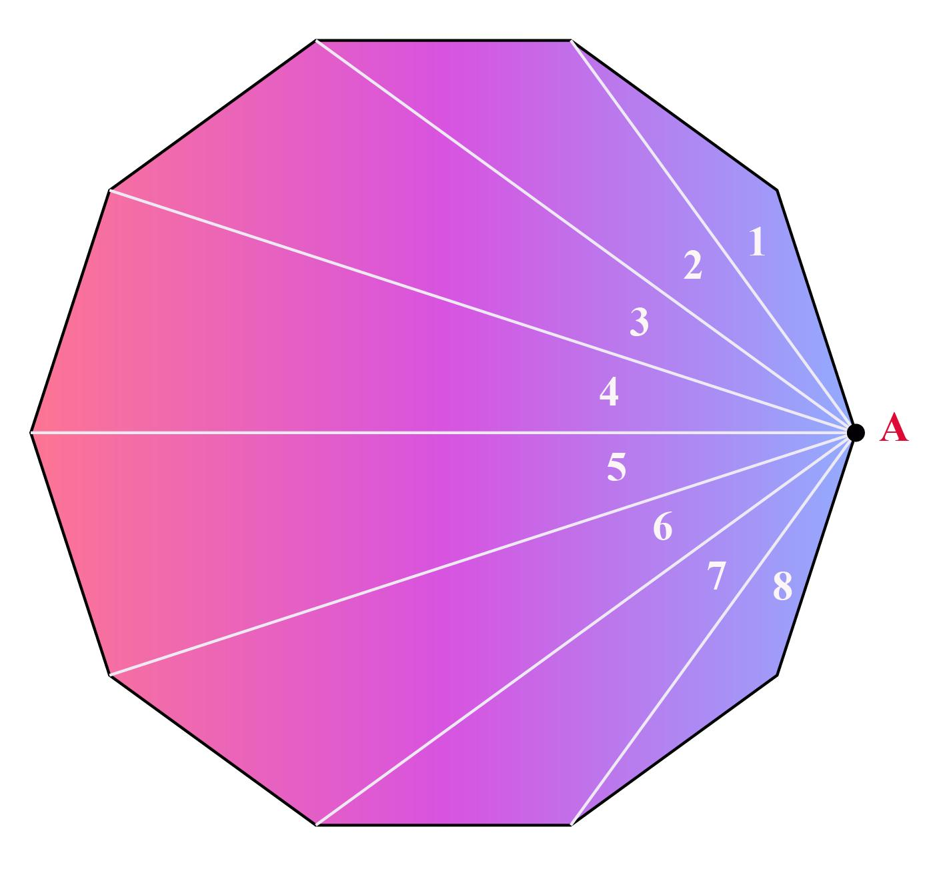
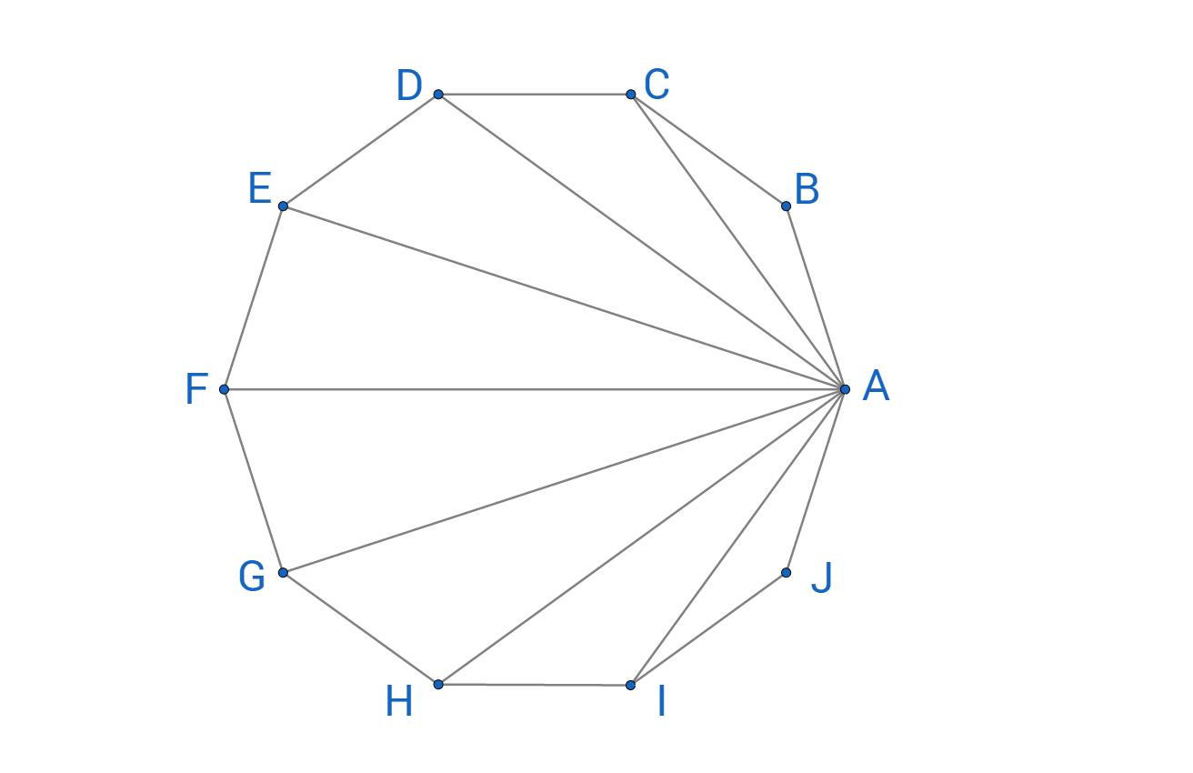
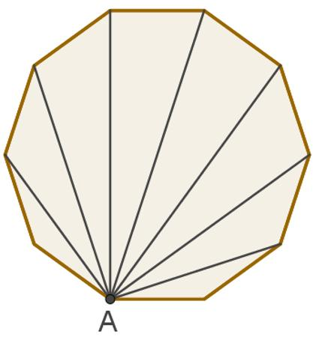
For a decagon $ABCDEFGHIJ$, choose $A$as the fan vertex.
Draw:
$$\overset{‾}{AC},\overset{‾}{AD},\overset{‾}{AE},\overset{‾}{AF},\overset{‾}{AG},\overset{‾}{AH},\overset{‾}{AI}$$
There are:
$$10-3=\boxed{7}$$
diagonals.
They produce:
$$10-2=\boxed{8}$$
triangles.

Convex Polygon Fan Triangulation
# Source: AI Source: Provided by: [Data Path: Persons Table -> ID Column: 1, Name_En Column: Motasem Essam] -> From: [ChatGPT] on [7/25/2026]
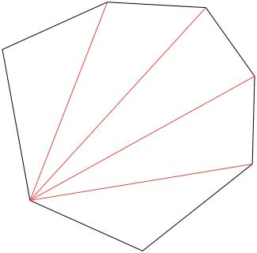
Fan triangulation is especially straightforward for convex polygons.
Every diagonal from the selected vertex to a non-adjacent vertex lies inside the polygon.
Therefore, any vertex can generally be selected as the fan vertex.

Concave Polygon Fan Triangulation
# Source: AI Source: Provided by: [Data Path: Persons Table -> ID Column: 1, Name_En Column: Motasem Essam] -> From: [ChatGPT] on [7/25/2026]
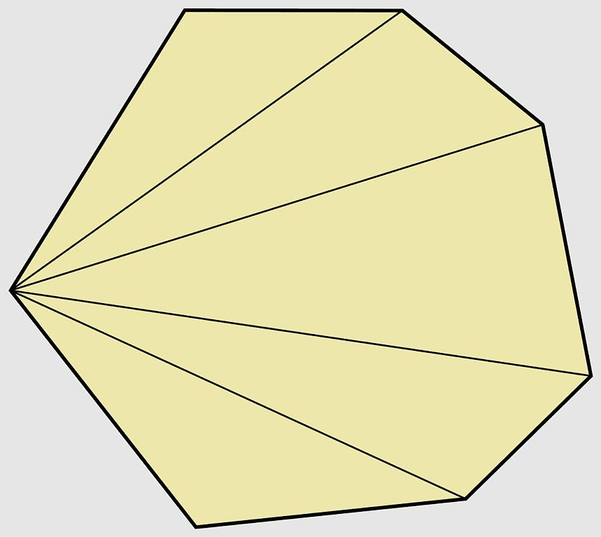
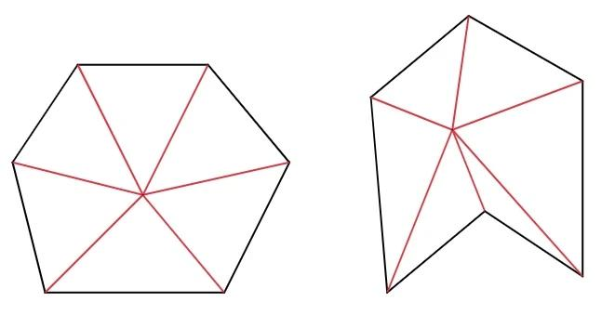
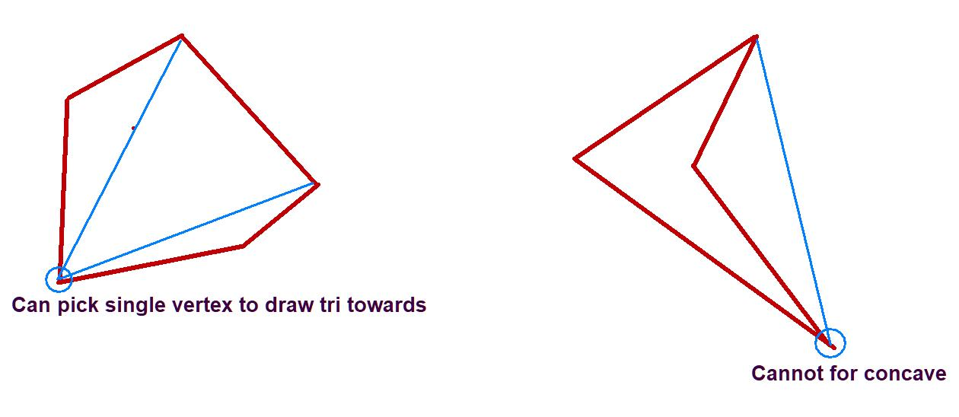
For a concave polygon, selecting a vertex arbitrarily may cause some connecting segments to lie outside the polygon.
Therefore, a fan triangulation is valid only when all selected diagonals lie inside the polygon and do not cross improperly.
A suitable vertex can be chosen so that its fan diagonals form a valid triangulation.

Properties
# Source: AI Source: Provided by: [Data Path: Persons Table -> ID Column: 1, Name_En Column: Motasem Essam] -> From: [ChatGPT] on [7/25/2026]
Fan triangulation has the following properties:
- It uses one common vertex.
- All triangulation diagonals originate from that vertex.
- The diagonals do not cross each other except at the common fan vertex.
- An $n$-gon requires exactly $n-3$fan diagonals.
- It produces exactly $n-2$triangles.
- The resulting triangles share the fan vertex.
- For a convex polygon, any vertex can serve as the fan vertex.
- For a concave polygon, the chosen vertex must allow all fan diagonals to remain inside the polygon.

Fan Triangulation and Interior Angles
# Source: AI Source: Provided by: [Data Path: Persons Table -> ID Column: 1, Name_En Column: Motasem Essam] -> From: [ChatGPT] on [7/25/2026]
Fan triangulation provides a direct way to determine the sum of the interior angles of a polygon.
An $n$-gon produces:
$$n-2$$
triangles.
Since every triangle has an angle sum of ${180}^{∘}$:
$$\boxed{S=\left(n-2\right){180}^{∘}}$$
For example, a decagon produces 8 triangles:
$$8×{180}^{∘}=\boxed{{1440}^{∘}}$$

Fan Triangulation and Polygon Area
# Source: AI Source: Provided by: [Data Path: Persons Table -> ID Column: 1, Name_En Column: Motasem Essam] -> From: [ChatGPT] on [7/25/2026]
Fan triangulation can also be used to calculate the area of a polygon.
If the fan produces $n-2$triangles:
$$\boxed{A_{\text{polygon}}=A_{1}+A_{2}+⋯+A_{n-2}}$$
For each triangle:
$$A_{i}=\frac{1}{2}b_{i}h_{i}$$
Therefore:
$$\boxed{A_{\text{polygon}}=\sum_{i=1}^{n-2}{\frac{1}{2}}b_{i}h_{i}}$$
This is particularly useful for irregular polygons.

Fan Triangulation vs. General Triangulation
# Source: AI Source: Provided by: [Data Path: Persons Table -> ID Column: 1, Name_En Column: Motasem Essam] -> From: [ChatGPT] on [7/25/2026]
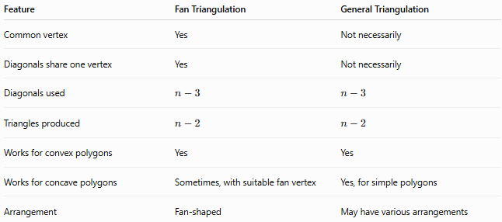
Feature | Fan Triangulation | General Triangulation
Common vertex | Yes | Not necessarily
Diagonals share one vertex | Yes | Not necessarily
Diagonals used | $$n-3$$ | $$n-3$$
Triangles produced | $$n-2$$ | $$n-2$$
Works for convex polygons | Yes | Yes
Works for concave polygons | Sometimes, with suitable fan vertex | Yes, for simple polygons
Arrangement | Fan-shaped | May have various arrangements
Important: Fan triangulation is a specific type of triangulation, not a different result in terms of the number of triangles.

Advantages
# Source: AI Source: Provided by: [Data Path: Persons Table -> ID Column: 1, Name_En Column: Motasem Essam] -> From: [ChatGPT] on [7/25/2026]
- Simple to construct.
- Easy to understand.
- Uses a single reference vertex.
- Requires exactly $n-3$diagonals.
- Produces exactly $n-2$triangles.
- Convenient for calculating polygon area.
- Particularly simple for convex polygons.

Limitations
# Source: AI Source: Provided by: [Data Path: Persons Table -> ID Column: 1, Name_En Column: Motasem Essam] -> From: [ChatGPT] on [7/25/2026]
- Not every vertex can necessarily be used for a fan in a concave polygon.
- Some fan diagonals may fall outside a concave polygon.
- It may not be the most suitable triangulation for certain computational or geometric applications.
- Different choices of fan vertex can produce different triangle shapes.

Relationship with Other Triangulation Types
# Source: AI Source: Provided by: [Data Path: Persons Table -> ID Column: 1, Name_En Column: Motasem Essam] -> From: [ChatGPT] on [7/25/2026]
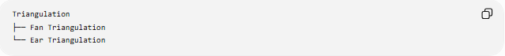
Triangulation
├── Fan Triangulation
└── Ear Triangulation
Fan triangulation is based on one common vertex, whereas ear triangulation repeatedly removes ears from the polygon.

Key Points
# Source: AI Source: Provided by: [Data Path: Persons Table -> ID Column: 1, Name_En Column: Motasem Essam] -> From: [ChatGPT] on [7/25/2026]
- Fan Triangulation divides a polygon into triangles from one selected vertex.
- The selected vertex is the fan vertex.
- Every triangulation diagonal begins at the fan vertex.
- An $n$-gon uses $n-3$diagonals.
- It produces $n-2$triangles.
- For a convex polygon, any vertex can normally be selected.
- For a concave polygon, the fan vertex must be chosen carefully.
- It can be used to determine polygon angle sums and areas.
- It is one of the simplest forms of polygon triangulation.

Conclusion
# Source: AI Source: Provided by: [Data Path: Persons Table -> ID Column: 1, Name_En Column: Motasem Essam] -> From: [ChatGPT] on [7/25/2026]
Fan Triangulation is a simple and important type of polygon triangulation in which all triangulation diagonals originate from one common vertex. For an $n$-sided polygon, it uses $n-3$diagonals to create $n-2$triangles, making it especially useful for analyzing polygon angles and calculating polygon areas.

